Synopsis of New Features in ZFP Tools
V3.6.2.0

Overview

The main new features of v3.6.2.0 are to do with error handling and validation. There are two other new features – a validation facility and the ability to automatically load the file that you were last working on when you start up the program.

Automatically reload the last file you were working on

Current the program loads a default template on start up, and that is still the default action. However by ticking the checkbox shown below the last file you were working on is loaded instead.

New Validation button

When you send a configuration to a panel, it is validated before sending, and if errors are found, it is not sent. That process has been improved and extended, plus it is now possible to do that validation without attempting to send to the panel by clicking the button below on the Node view tab.

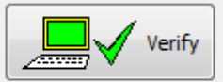

Improved Error Handling

Error handling has been improved. I errors are found, either through attempting to send data or through pressing the Verify button, you get a message very similar to the one you got previously

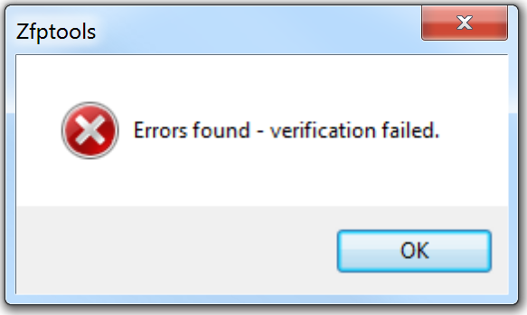

However there is now a detailed error window listing all the errors and warnings found. Note that errors will stop a transfer, but warnings will not. For example an empty output zone in the cause and effects is likely to be wrong, but is not necessarily, so this is a warning, not an error. The list of errors might look something like this

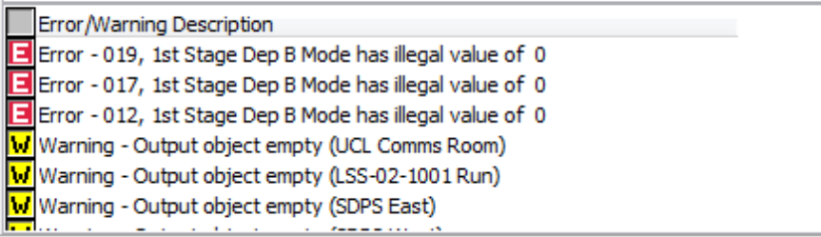

One of the errors will be highlighted and the page where this error occurs will be automatically shown, making it easy to correct errors. To go to another error or warning, just double click on it. You can also progress up and down the error list by clicking Alt+N to go to the next error/warning and Alt+P to go to the previous one. Once you have dealt with an error, you might want to remove it. You can do this by pressing Alt-X. You can close the error list altogether by right clicking and selecting ‘Close’. (You can move through the list the same way, but the keyboard shortcuts are quicker.

